2026 Python HW1
School number: 01372149
Name: 江其恩


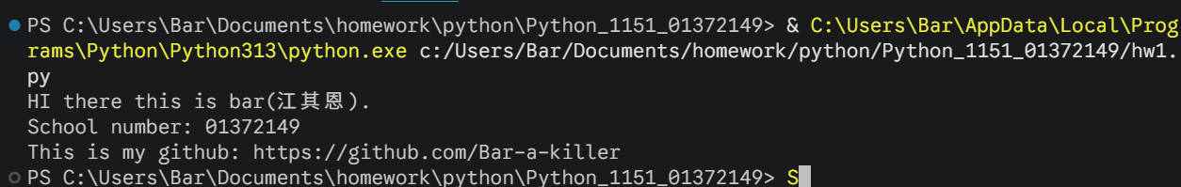
https://github.com/Bar-a-killer/homework/tree/master/colledge/python

